––
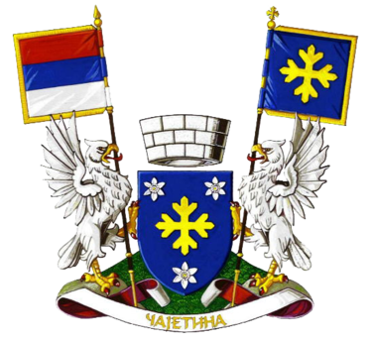

The European Cultural Heritage: Tell Your Story!

Name, Surname: Danilo Božanić
Age: 23
Town: Čajetina / Zlatibor
Country: Serbia

The story about “Slava”

Slava is a Serbian holiday when everyone is celebrating patron saint of their house. Customs of each slava differ from place to place, as our saying goes ”100 villages – 100 customs”, but they all follow some core guidelines, so the customs of our slava we usually learn from our relatives, mainly from fathers and grandfathers.
In my case I learned mostly from my father, but also some from my grandmother. Slava is a holyday inherited purely by male lineage so each surname is accompanied with a fixed patron saint. As one of the most important holydays in Serbia there is even a law stating that you must have a day off on the day of your slava so you can celebrate, it applies on children as well as adults. My family celebrates slava on 21st November, our patron saint is archangel Michael.
Preparation of a slava starts couple of days earlier because you need to make lots of food and a great variety of it, also drinks and all the other little things you need because you will have guests in your house for a whole day, even two days sometimes.
On the day of slava someone from the house, usually the man of the house, gets up very early and takes round bread that is previously carefully prepared, which is decorated with religious symbols made out of dough, to the church to have it blessed by the local priest, and a big candle with a picture of the saint is put at the head of the table that is lit in the morning.
After that is over, the guest start arriving and they will be coming and going for the whole day, because many people you may know celebrate the same saint, at about noon the main lunch starts. The main lunch is the most important part of slava, we start by burning some incense and saying a prayer while everyone is standing after that the person who is seated at the head of the table and the head of the house take the blessed bread spin it three times while saying another prayer and after that is over they break it in half together and drink some rakija that is counted as a first toast, each piece has a meaning and is given to the male heir and the woman of the house.
After the ceremony the lunch starts and goes on normally until the fourth toast which is toasted with Buklija, it is a bowl full of red wine or rakija, depends on the house, which is sweetened with sugar and has three apples floating in it. Buklija is drank by taking three sips and then toasting to the person opposite of you at the table, you do not toast to the person beside you, and it goes on until everyone has had a few sips.
After that it’s just eating, drinking and having fun, even sometimes singing. The host is not allowed to sit while the guests are there, but you cannot stand for a whole day so you eventually sit down.
Slava is the personification of Serbian hospitality because anyone can come, even without knowing you, and everyone is always welcome.

