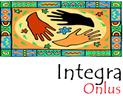
––
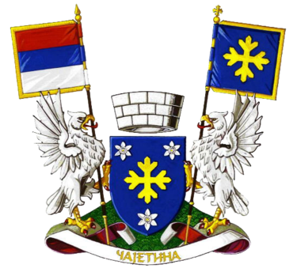

The European Cultural Heritage: Tell Your Story!

Name, Surname: A group of 40 karate club members from Municipality of Čajetina
Age: 8–15 years
Town: Čajetina / Zlatibor
Country: Serbia

Description:
People lull into everyday life and forget to recount important events that have happened in the past.
Walking along the same routes of the Zlatibor mountain, one of the trails leads to the most visited Šumatno hill, on this mountain.
In a company of young karate club members, age 8–15 years, we visited Šumatno hill and started the story about the memorial that is located there. It is located about 5 kilometers from the center of Zlatibor. There is a monument on it.
Asking the children if they knew to whom the monument was erected, their answer was that it was erected to the executed partisans.
According to the legend, during the attack on the Republic of Užice, German soldiers trampled and shot the captured partisans. After the Second World War, an ossuary was built on the hill above Zlatibor, which housed the remains of 150 wounded. It was built in October 1961. by the Association of Fighters of the Municipality of Čajetina.
A 10-meter-high white stone obelisk was erected above the ossuary in 1967 by architects Jovanka Jeftanović and sculptor Ana Bešlić. On the front of the obelisk are carved folk motifs and verses by Vasko Popa: “I do not give this sun in my eyes, I do not give this bread in the palm of my hand.”
Telling them this story about individuals who fought for the homeland, learning the details, the little listeners were dumbfounded, obsessed and with admiration they looked at the memorial, imagining the battles.
For them, this was an important moment learning what it actually represents. Earlier, they heard only a part of the story, but the cultural heritage is not only a part, but the whole history that is passed from generation to generation.
The national cultural heritage is a part of ourselves, where only by getting to know our past well can we build a stable future on solid roots.
Carried away by impressions, they leave with a well-remembered sentence engraved: “Ne dam ovo Sunca u očima, ne dam ovo hleba na dlanu.”

